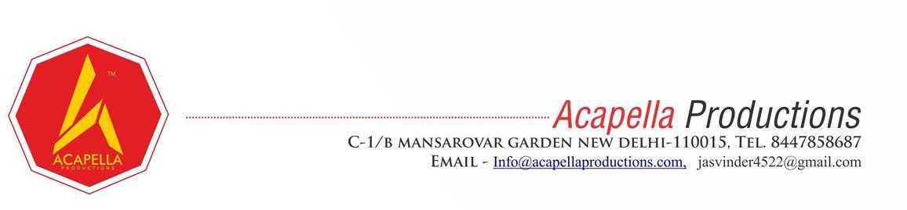

Ref: Acapella/EL/26-27/102 Date: 30.08.2026
Sub: Experience Letter
To whomsoever it may concern
This is to certify that Ikshu Goel has successfully completed her internship with Acapella Productions as a Database Management Intern from May 05, 2026 to August 06, 2026.
During the internship period, Ikshu demonstrated exceptional technical skills, professionalism, and a strong aptitude for problem-solving and innovation. She was primarily responsible for assistance in managing database records, optimizing queries, and assisting with data organization, proving to be efficient, reliable, and highly effective in achieving the intended goals.
During this tenure, we found him very sincere, creative, and hardworking. This is to confirm that she has been relieved from all his responsibilities and holds no dues towards the company.
We take this opportunity to thank her and wish her success in her future endeavours. Warm regards,
Acapella Productions

